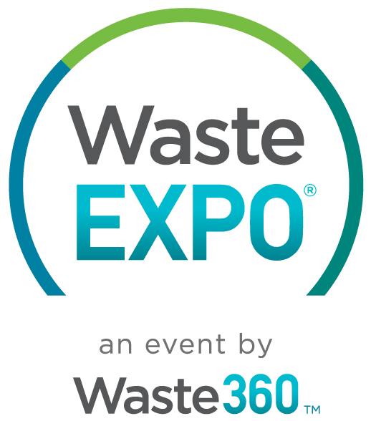
May 9-12, 2022
Las Vegas Convention Center, West Hall
Las Vegas, NV
www.wasteexpo.com

Dear [ENTER MANAGER’S NAME],

I’m requesting your approval to attend WasteExpo 2022 (May 9-12, 2022 in Las Vegas). As you may know, this event is the leading waste, recycling, and organics event in North America, and it has been going strong for 50+ years.

I’ve been exploring the WasteExpo agenda—and am excited about the interactive conference program, valuable networking opportunities, and abundance of solutions that will be on display. I hope you’ll agree that it would be worthwhile for me (and, in turn, our entire department can benefit).

Here are some facts and highlights about WasteExpo 2022 that you may find useful:

- 600+ exhibitors will be there, with solutions to our organization’s challenges. I’ll be able to research the latest products hands-on and meet vendors and partners that can help us tackle our challenges. This is the industry’s largest exhibit hall with more solutions than ever.
- A more essential, interactive conference program that will help me do my job better. Taught by industry experts, this year’s conference program will have technology and innovation as underlying themes. And returning this year are FREE Spotlight sessions focused on the industry’s hottest topics.
- There will be special educational tracks focused on (insert appropriate topics from this list): Recycling/Resource Recovery, MRFS/Transfer Stations/Waste-to-Energy, Safety, Leadership/Business Development/Finance, Regulatory, Fleet and Equipment Technology, Technological Innovations in the Waste & Recycling Industry, Landfill Technologies/Best Practices, Hauling, Composting & Organics Recycling], which are of particular interest. These targeted sessions will provide the latest insights on pressing topics related to my job and our department.

- For taking part in the educational offerings, I’ll get a Certificate of Attendance—time and money well spent.

I’m confident that WasteExpo 20212will directly influence my work on [PROJECT NAME] and help with my goal of [INSERT GOAL]. I’ll also be happy to share event takeaways, insights, and recommendations with you and/or our whole team.

To take full advantage of WasteExpo 2022, the Premium Package is the most cost-effective option. The price is lowest if I register before 3/10/2022. Also, to make travel and accommodations easier, WasteExpo has secured discounts on flights and hotels—and I would plan to take advantage of these deals.

WasteExpo will be the only opportunity all year to connect with thousands of experts, peers, and providers in our industry—from the U.S. and around the world. I feel strongly that it’s an event that can benefit our entire department and our organization’s bottom line.

Thank you for your consideration!

Regards,
[YOUR NAME]

PS: You can visit www.wasteexpo.com to see why it’s worth the investment.

